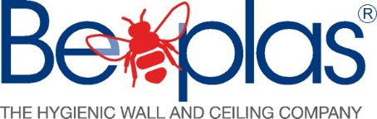

BENEFITS OF USING MULTIBEAD ADHESIVE SYSTEM IN COMPARISON TO TRADITIONAL TWO COMPONENT ADHESIVE SYSTEM

BENEFITS | MULTIBEAD WITH A G2 APPLICATOR GUN | 2 COMPONENT POLYURETHANE ADHESIVE
User | No contact with skin so user keeps clean. | Using a hand trowel for application is messy and gets over skin and clothes.
Application speed | Battery powered applicator gives a very quick adhesive application. | Trowel application is slow and laborious.
Consistent application | Bead application through the nozzle gives a consistent adhesive coverage. | Trowel application is susceptible to user inconsistencies in application.
Clean up | Hybrid polymer adhesive is easy to clean up. | Polyurethane adhesive requires solvent clean up and is difficult to remove from skin.
Ergonomics | No bending over or user force required. | Trowelling can cause user fatigue.
Solvent content | Negligible VOC content. | Harmful chemical content.
Ability to bond to damp substrates | Uses moisture to cure so can bond surfaces whilst still damp. | Substrates need to be below 14% RH
Tool cleaning | Disposable nozzle system does not require cleaning, although the gun does need to be kept clean and any overspill removed. | Trowels need to be cleaned.
Packaging | Aluminium sachets reduce to a very small disc and are easy to dispose of. | Plastic containers are bulky and difficult to dispose of.
Bond strength | Meets strength required for bonding PVC wall cladding. | Meets strength required for bonding PVC wall cladding
Extra benefits:
Disposable nozzle- replacement nozzles are provided with the adhesive sachets
Be-Plas Hygienic Walls and Ceilings Ltd
Junction 8 Business Park, Ellesmere Port, CH65 3AS
Tel: 0151 356 5727 Email: sales@beplas.com Website: beplas.com

